**Chapter 1**

**Introduction**

Indian Premier League (IPL) is the most popular sports event in India with huge amount of cash flow on and off the pitch. As IPL gains more popularity, it attracts more endorsement for each team. So, prediction of a match result is very much important for the sponsors as it will help them to put their investment in good hands. In this study we build a Logistic model by which it has been shown that for a particular team, Points table, match list, top 10 performers and the IPL trophies.

IPL Database Management is a cricket scheduling-based application exclusively for the game of cricket. The Application features schedules, information about teams, records of batting and bowling, creating new schedules, can search about players, it displays rank tables for teams and players.

**1.1 Problem Statement**

Aim of the project is to develop a GUI for users to access the IPL Information and for Admin to add the information of the IPL

**1.2 Tools and Technologies**

Tool: XAMPP server, My SQL

Programming language: PHP, Html(Hypertext preprocessor)

DBMS: Mysql database

**1.2.1 Introduction to Xampp server**

XAMPP is a free and open source cross platform web server solution stack package developed by Apache Friends, consisting mainly of the Apache HTTP Server, Maria DB database, and interpreters for scripts written in the PHP and Perl programming languages. XAMPP stands for Cross-Platform, Apache, Maria DB, PHP and Perl. It is a simple, lightweight Apache distribution that makes it extremely easy for developers to create a local web server for testing and deployment purposes. Since most actual web server deployments use the same components as XAMPP, it makes transitioning from a local test server to a live server extremely easy as well.

**1.2.2 Introduction to MySQL**

MySQL is the world's most popular open source database. With its proven performance, reliability and ease-of-use, MySQL has become the leading database choice for web-based applications, used by high profile web properties including Facebook, Twitter, YouTube, Yahoo! and many more. Oracle drives MySQL innovation, delivering new capabilities to power next generation web, cloud, mobile and embedded applications.

Mysql name contains SQL which is abbreviated as Structured Query Language. It is used in this project for designing of backend.

**Chapter 2**

**System Analysis**

System analysis the process of observing systems for troubleshooting or development purposes. It is applied to the information technology, where computer base systems required defined analysis according to their makeup and design.

**2.1 Proposed Systems**

The project is mainly aimed to create software which provides IPL information access to the user.

**2.2 Existing System**

In existing system, already these concepts are implemented and we are recreating some of those concepts for the learning purpose.

**Chapter 3**

**System Requirement Specification**

**3.1 Functional Requirements**

**1. User**

* Users shall be able to view IPL teams and their Information
* Users shall be able to view Player Information
* Users shall be able to view Points table
* Users shall be able to view Batsman, Bowler detials.

**2. Admin**

* Admin shall Add or Delete Players.
* Admin shall Add or Delete Stadiums.
* Admin shall Add or Delete Schedules.
* Admin shall also search for player information.
* Admin shall view Stadiums, Rankings, Cricket Boards.
* Admin shall view players who got selected for match.
* Admin shall also update team and players rankings.
* Admin shall search for players in a particular match.

**3.2 Non Functional Requirements**

**1. Hardware Requirements:**

Processor : Intel PentiumT4200/ Intel Core Duo 2.0 GHz more

RAM : Minimum 1GB RAM capacity

Hard disk : Minimum 40 GB ROM capacity

Cache Memory : L2-1 MB

GPU : Intel HD Graphics

**2. Software Requirements:**

Front End : PHP(Hypertext preprocessor)

Back End : XAMPP server, My SQL

Operation System : Windows 7 Or Windows 8.1 Or Windows10

Client side : CSS (cascading Style sheet)

**Chapter 4**

**System Design**

**4.1 Data Flow diagram**

It describes the flow of data and the process that change data throughout a system. It is constructed using a set of symbols that do not imply physical implementations.

Admin

User

Cricket Database

**Figure-4.1 : Level -0 -DFD**

**4.2 Entity Relationship Diagram**

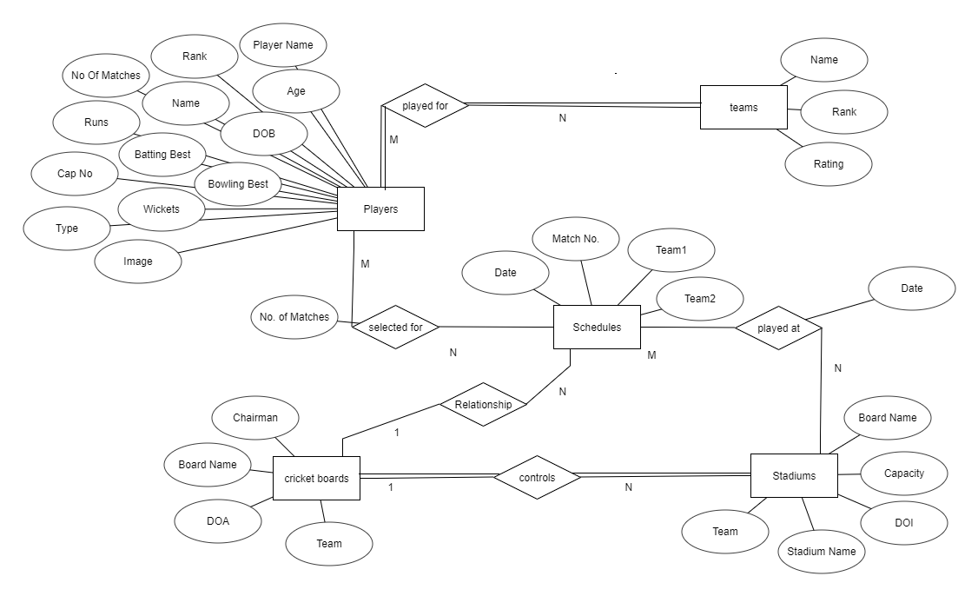 Figure 4.2: ER-Diagrams

**4.3 Schema Diagram**

Figure-4.3 : Schema Diagram of Entities in Cricket database

**Chapter 5**

**Implementation**

Implementation is the stage in the project where the theoretical design is turned into a working system and is giving confidence on the new system for the users that it will work efficiently and effectively. The system allows the user to enter the system only through proper user name and password.

**5.1 Function Modules**

**Create a connection to a database**

Before you can access data in a database, you must create a connection to the database. In PHP, this is done with the getConnection() function.

<?php

$con=mysqli_connect("localhost","root","","cricket");

?>

**Closing a Connection**

The connection will be closed automatically when the script ends. To close the connection before, use the close() function:

<?php

mysqli_close($con);

?>

**Stored Procedure**

DELIMITER $$

CREATE DEFINER=`root`@`localhost` PROCEDURE `stadium`()

NO SQL

select * from stadiums$$

DELIMITER;

**Trigger**

CREATE TRIGGER `default_date`

BEFORE INSERT ON `stadiums`

FOR EACH ROW

set new.DOI=CURRENT_DATE();

CREATE TRIGGER `update` BEFORE UPDATE ON `player`

FOR EACH ROW BEGIN

IF (new.runs<old.runs) THEN SET new.runs=old.runs;

IF (new.wickets<old.wickets) THEN SET new.wickets=old.wickets;

END IF;

IF (new.no_of_matches<old.no_of_matches) THEN SET new.no_of_matches=old.no_of_matches;

END IF;

END IF;

END

**Chapter 6**

**System Testing**

**6.1 Test Case and Test Results**

|  |  |  |  |  |
| --- | --- | --- | --- | --- |
| **Test** | **Test Case Title** | **System Behaviour** | **Expected** | **Observed Result** |
| **ID** | **and Condition** |  | **Result** |  |
|  |  |  |  |  |
|  | Primary Key | When Primary key | Duplication not | Dialog box |
| T01 | Integrity | is given duplicate | permitted | indicating |
|  | Constraint | value |  | corresponding |
|  |  |  |  | Error message |
|  |  |  |  |  |
| T02 | Null Values for | When all attributes | Primary key | The rows get |
|  | attributes except | of a given row are | cannot be null | inserted |
|  | primary key | null except primary |  |  |
|  |  | key |  |  |
|  |  |  |  |  |
| T03 | Insertion | When a valid values | One Row | Information |
|  |  | are given to a row | Inserted | inserted |
|  |  | and insert type |  | successfully |
|  |  |  |  |  |
| T04 | Search | When a valid search | Search | Result of the |
|  |  | is given | successful | search key is |
|  |  |  |  | given. |
|  |  |  |  |  |
| T05 | Display | When Search is | Successful | Information of all |
|  |  | successful |  | Accounts is given. |
|  |  |  |  |  |
| T06 | Click Exit | Application should | Successful | Closes the |
|  |  | get closed |  | application. |
|  |  |  |  |  |

**Chapter 7**

**Snapshots of the project**

**7.1 Snapshots**

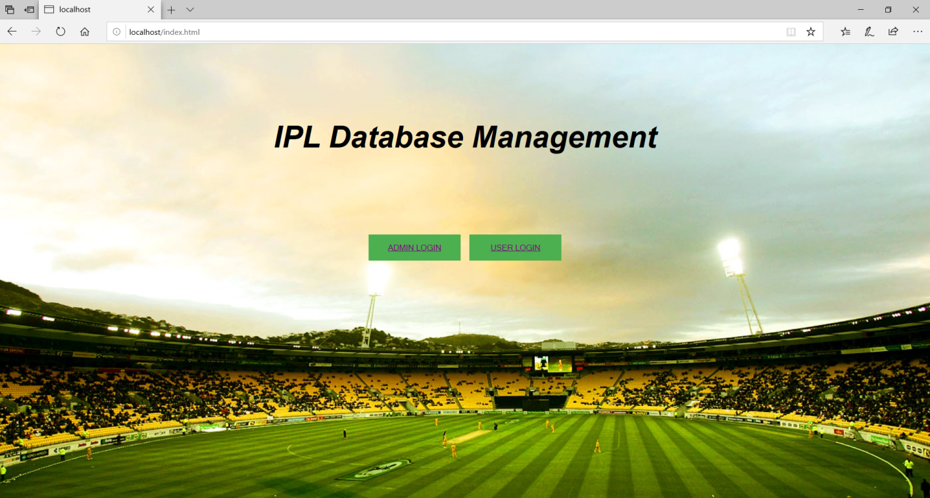

Figure7.1 Home page

In the above Figure7.1, It shows Home Page which allows to login as admin and also as a user.

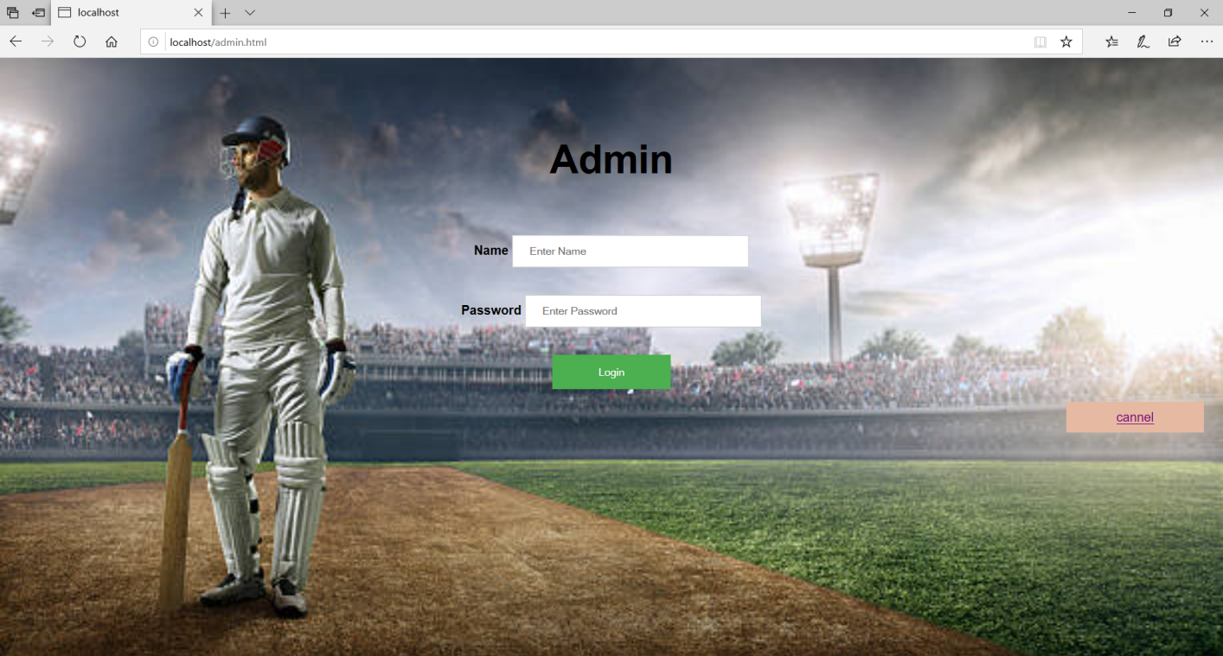

Figure7.2 Admin Login Page

In the above Figure7.2, It shows admin login page which gives authentication to enter into the Admin page.

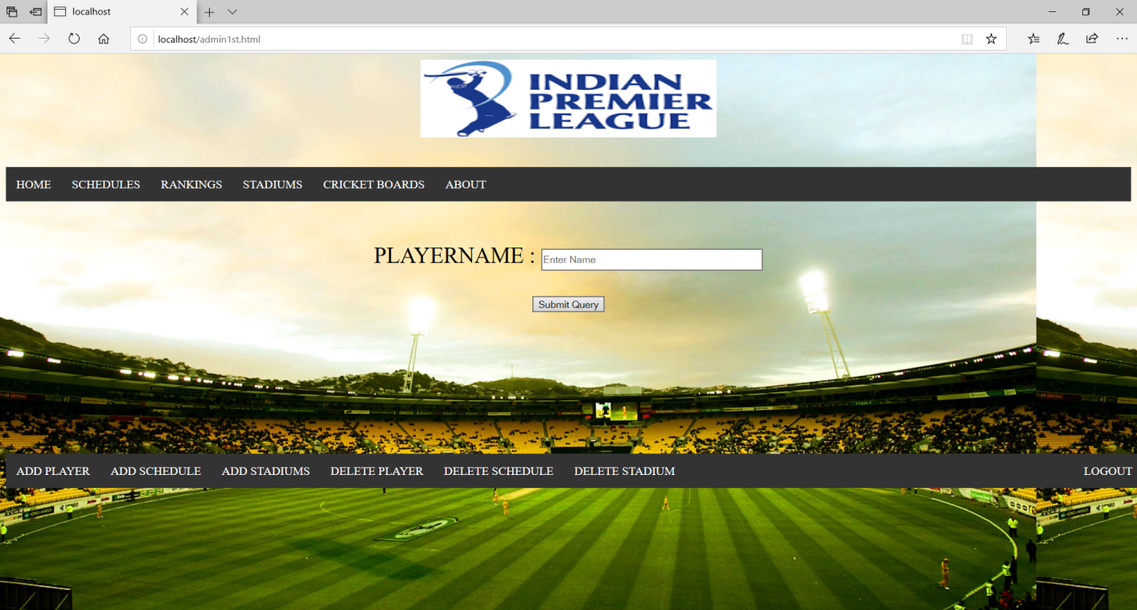

Figure7.3 Admin’s Home Page, In the above Figure7.3,shows windowwhich allows to add and delete of players, stadiums, schedules and can view schedules, rankings, stadiums, cricket boards and about page.

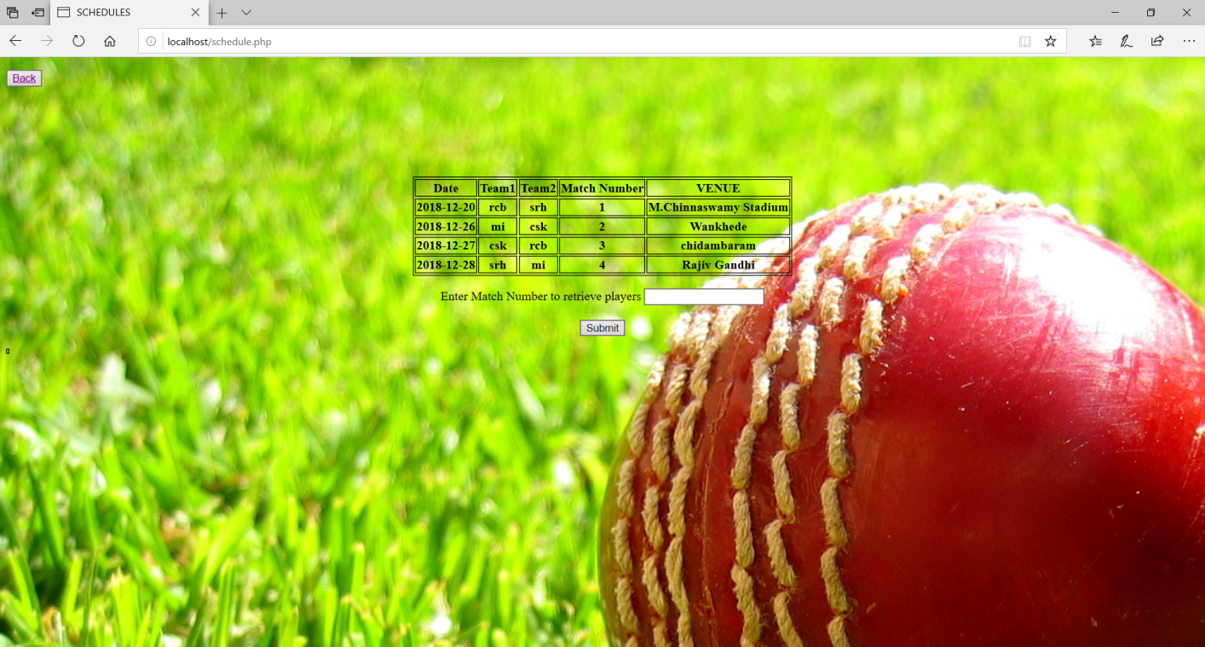

Figure 7.4 Schedules details

In the above Figure7.4, It shows columns that Schedules details of all matches that are present in the database and also search button for players who are playing that match.

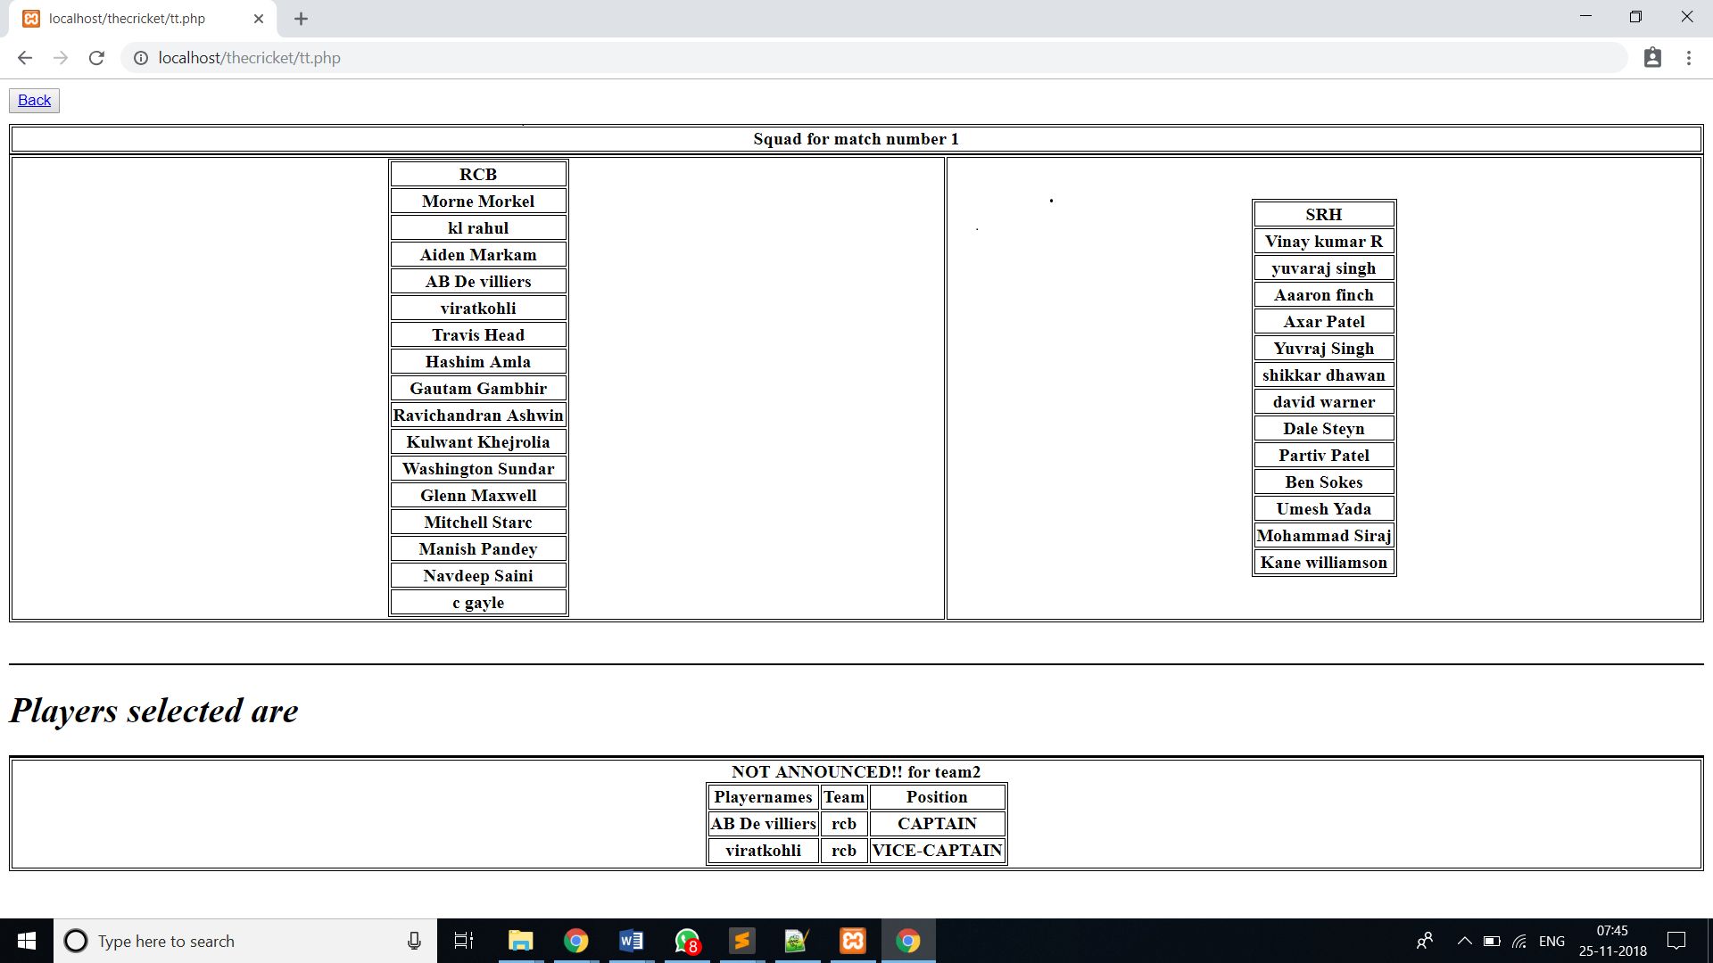Figure 7.5 Schedules details

In the above Figure 7.5, It shows columns that Showssquad available and players who got selected.

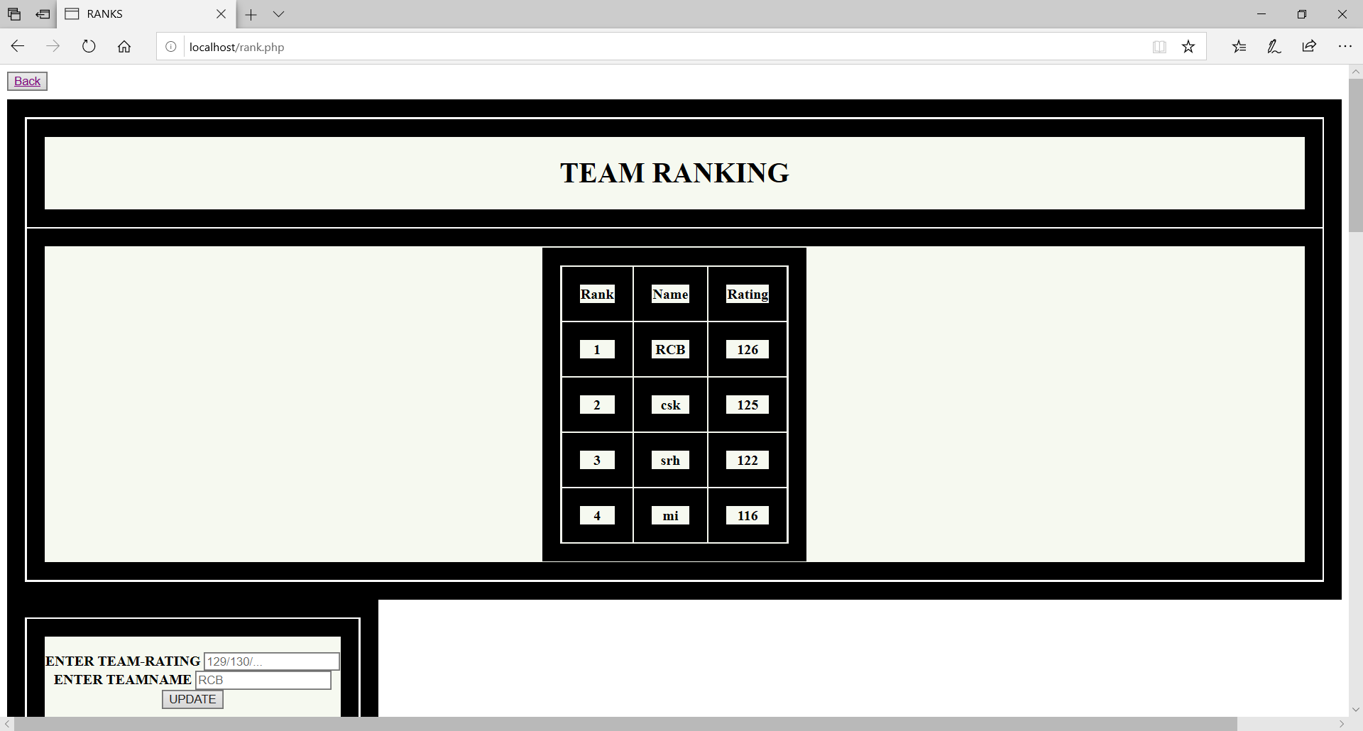Figure7.6Rankings In the above Figure7.6,It shows the window where updation of rankings available forteam and also for players by updating runs, wickets it shows their ranks in the table.

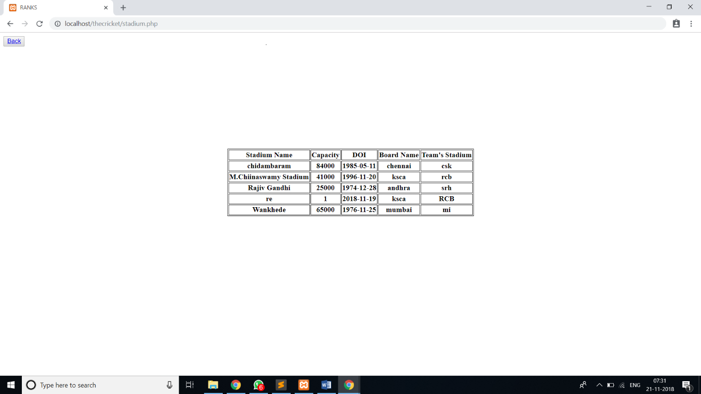Figure7.7 Stadium Details

In the above Figure7.7, Window shows updated Stadium details.

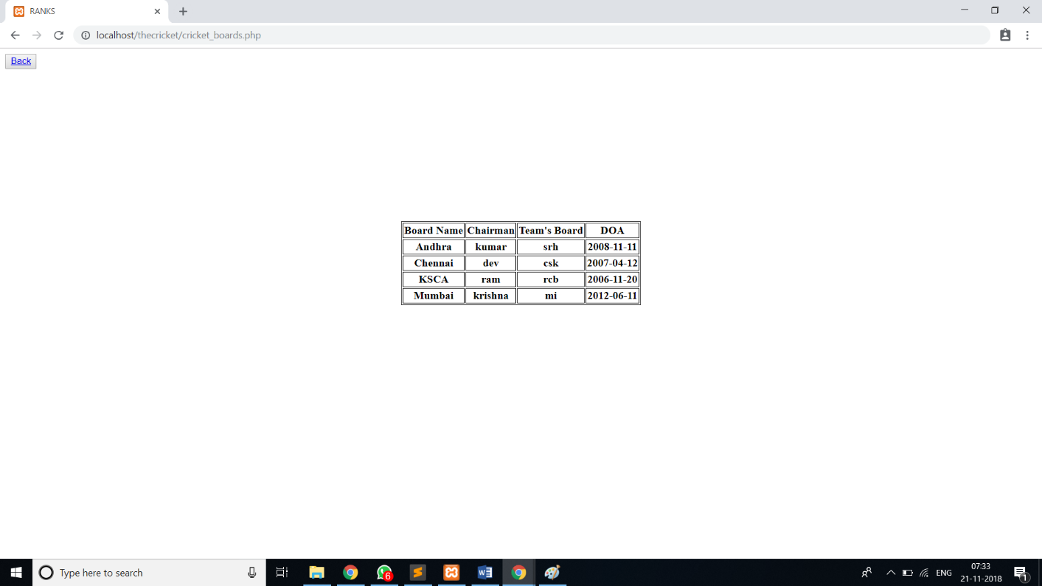

Figure7.8cricket boards information

In the above Figure7.8, Window displays information about cricket boards like their name,their chairman with which team’s board and date of inauguration.

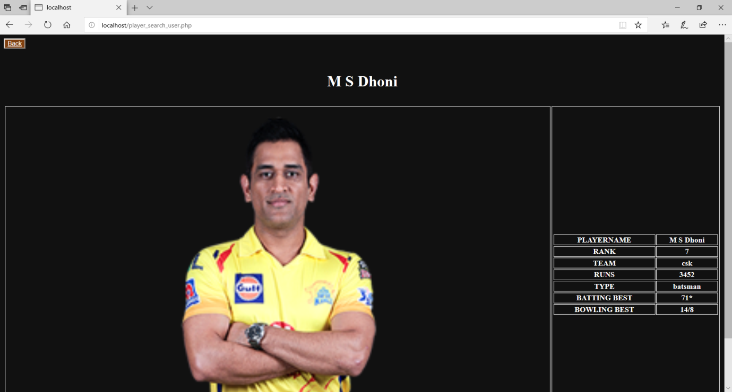

Figure7.9 Player search

In the above Figure7.9,It shows the window where we get Player search details.

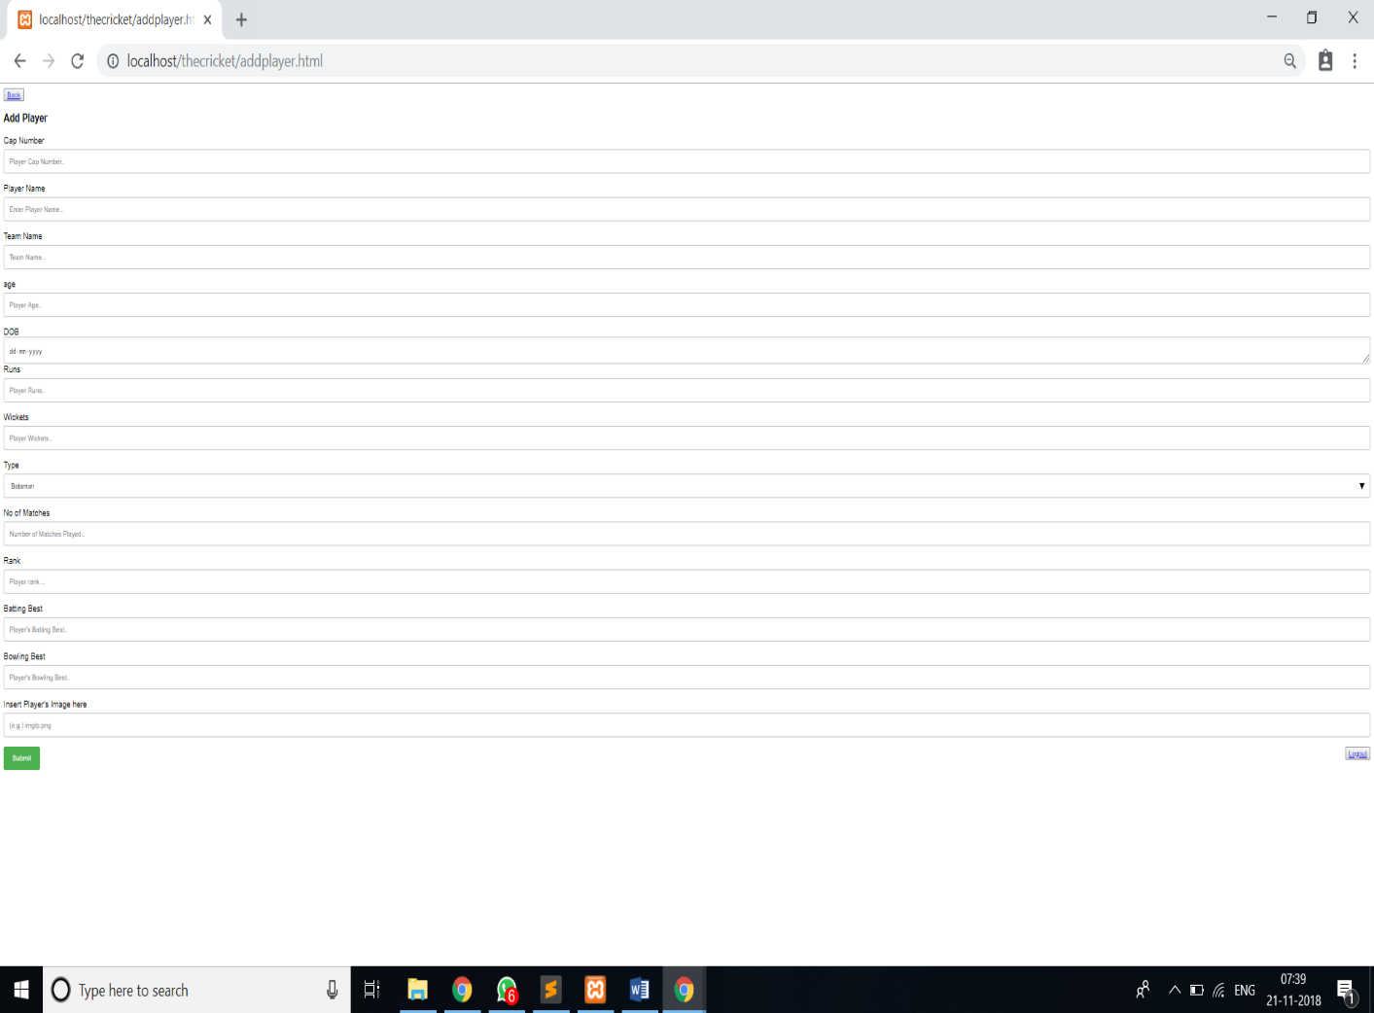

Figure7.10Add player

In the above Figure6.10, It shows window which allows admin to add player by his bio-data like cap number, player name, team name, age, DOB, runs, wickets, type, Number of matches played, rank, batting best, bowling best and his image.

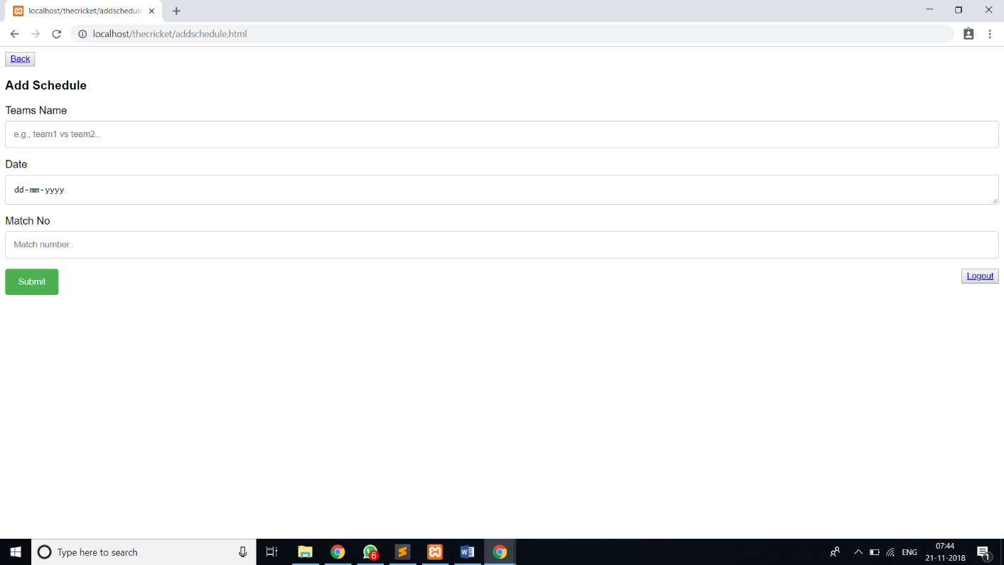Figure7.11 Add schedule

In the above Figure7.11,it shows window which allows admin to Add schedules for the matches in future by the team name, date and match number.

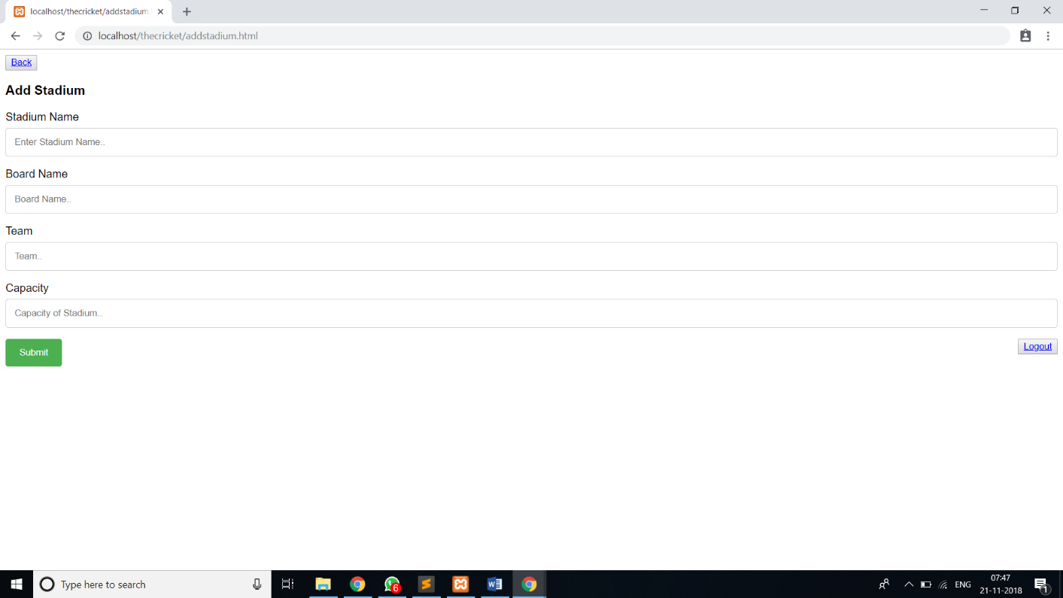

Figure7.12 Add Stadium

In the above Figure7.12, It shows window which allows admin to add stadium with stadium name, board name, team and Capacity.

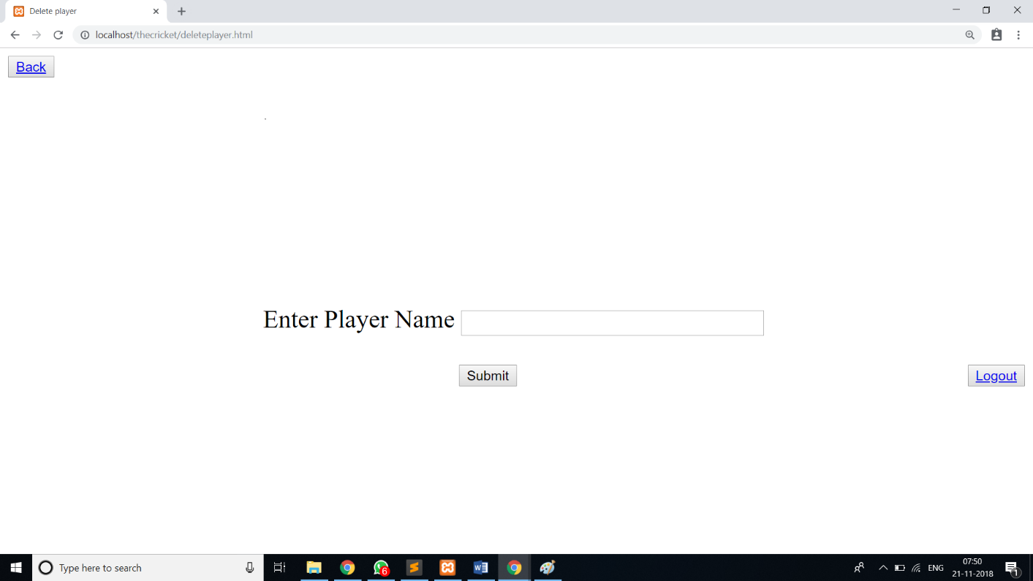Figure6.13 Delete player , In the above Figure7.13,it shows window which allows admin to delete a player by his name.

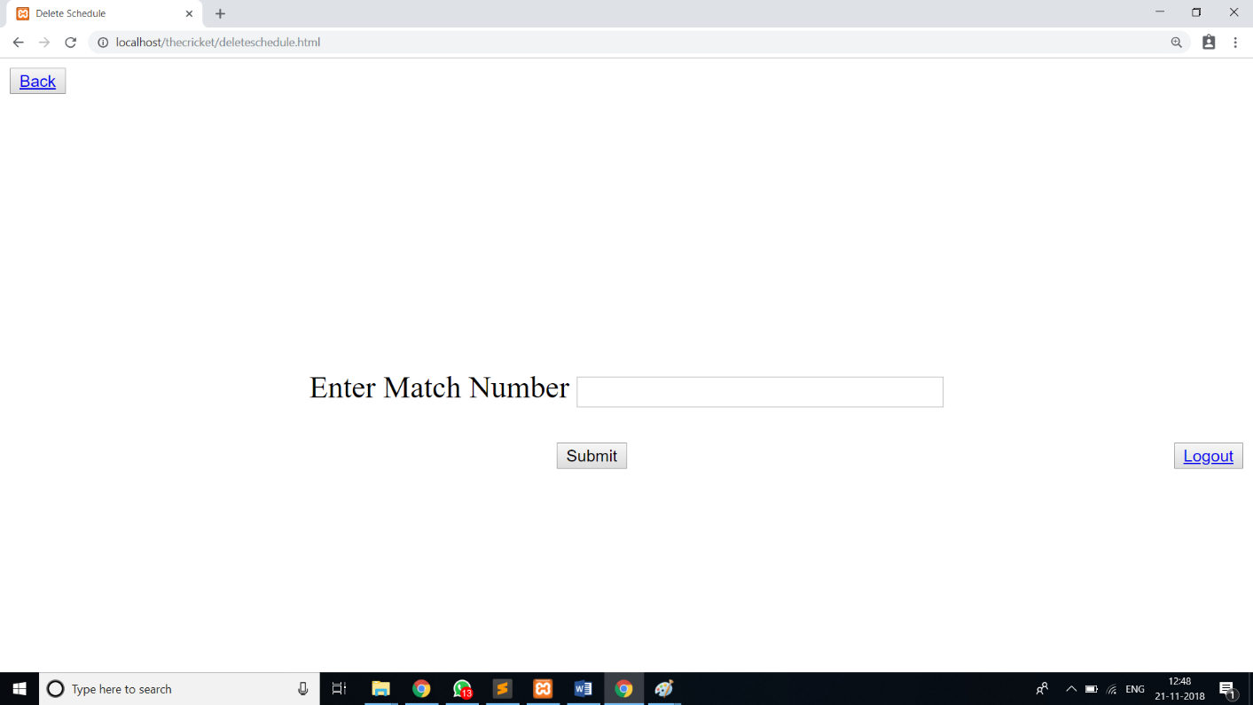

Figure7.14 Delete schedule, In the above Figure7.14,it shows window which allows admin to Delete a schedule by its match number.

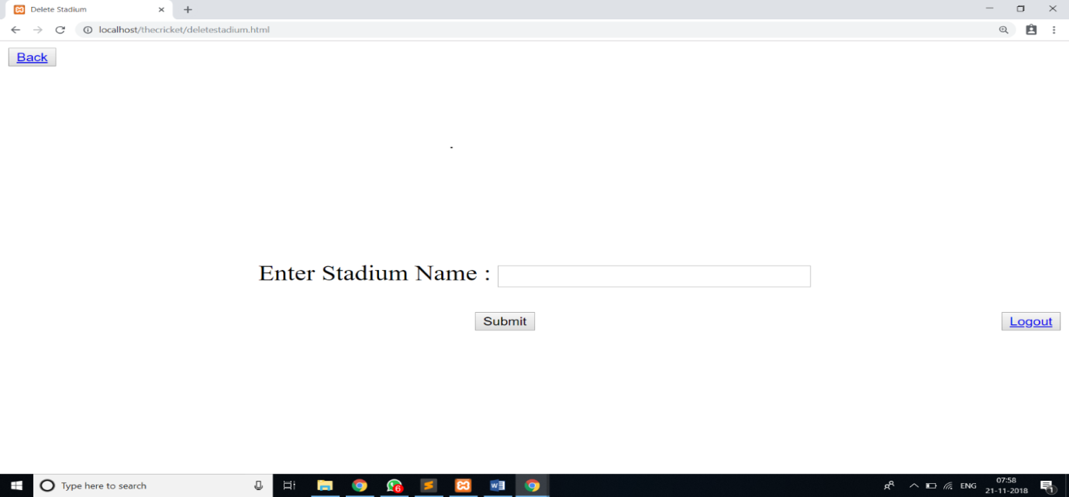

Figure7.15 Delete Stadium

In the above Figure7.15,it shows window which allows admin to Delete stadium by its name

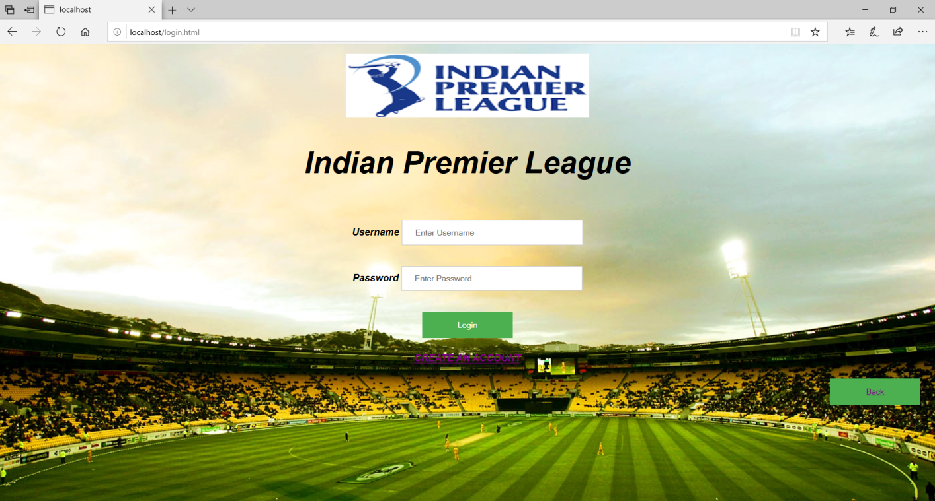

Figure7.16 User login page

In the above Figure7.16, It shows window which allows user to authenticate into user’s login page.

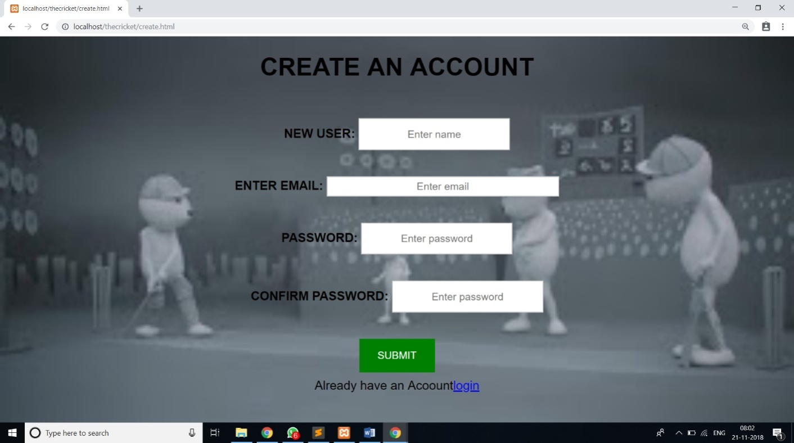Figure7.17 create an account page

In the above Figure7.17, it shows window which allows new users to Create an account.

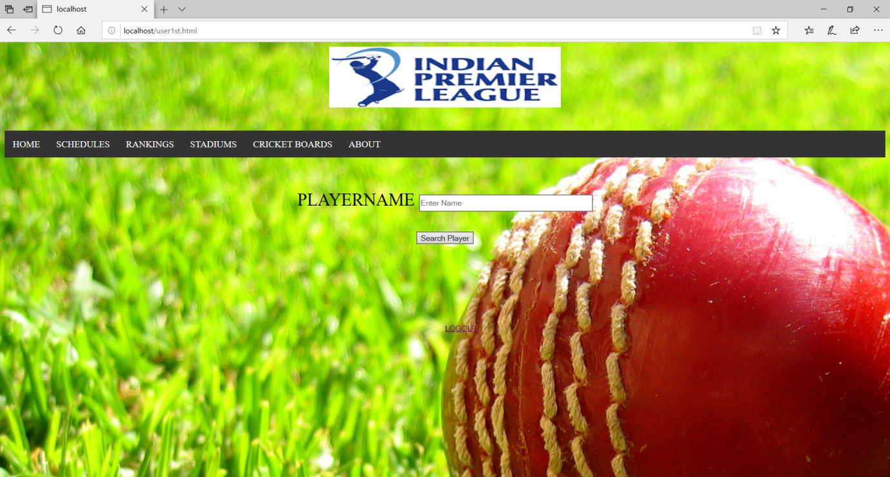

Figure7.18 Home page for users, In the above Figure7.18, It shows window shows Home page for users and it contains to search player’s information, schedules, rankings, stadiums, cricket boards and about IPL.

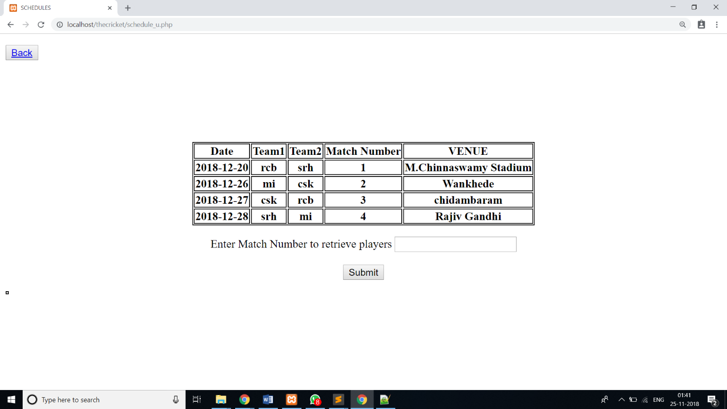Figure7.19 schedules

In the above Figure7.19,it shows window which gives information about schedules of future matches.

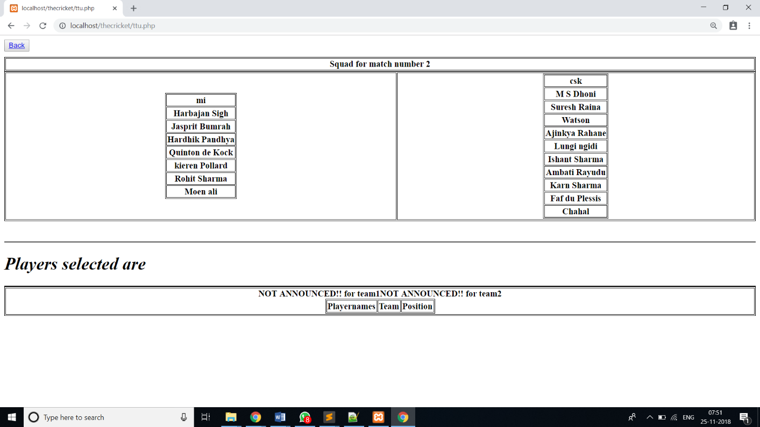

Figure 7.20 Schedules details

In the above Figure 7.20, It shows columns that Showssquad available and players who got selected.

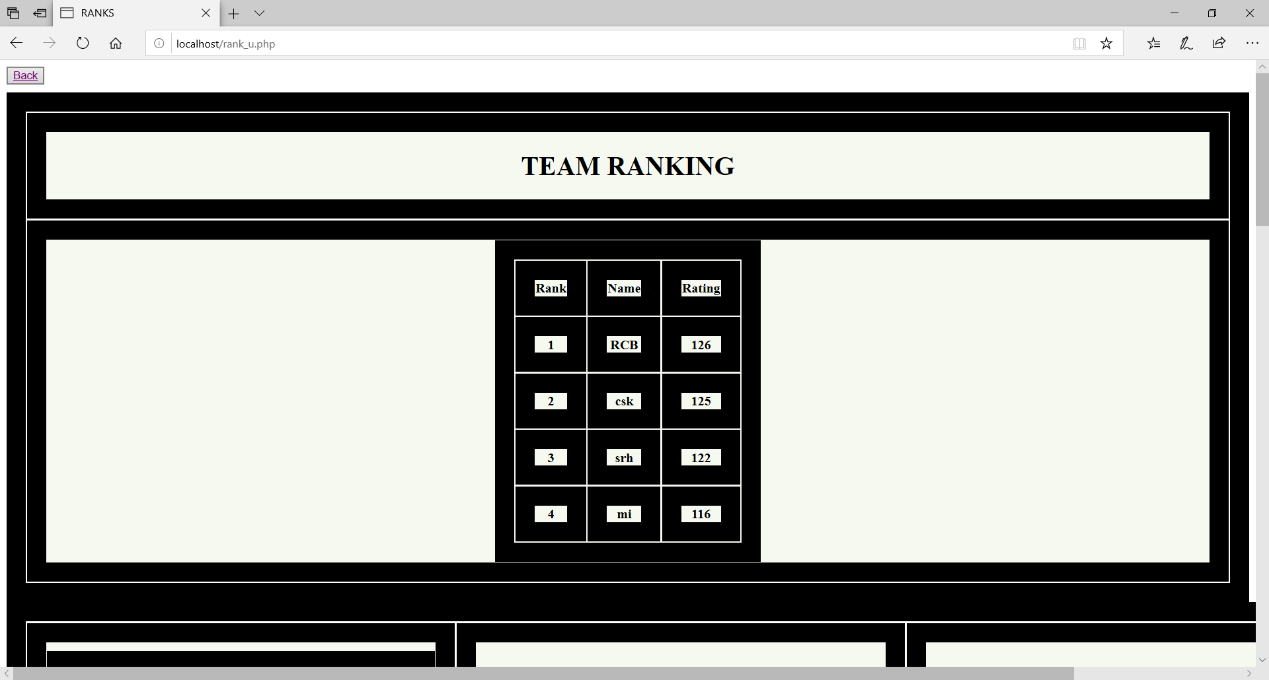Figure7.21 Rankings

In the above Figure7.21,it shows window that consists of team rankings and player rankings.

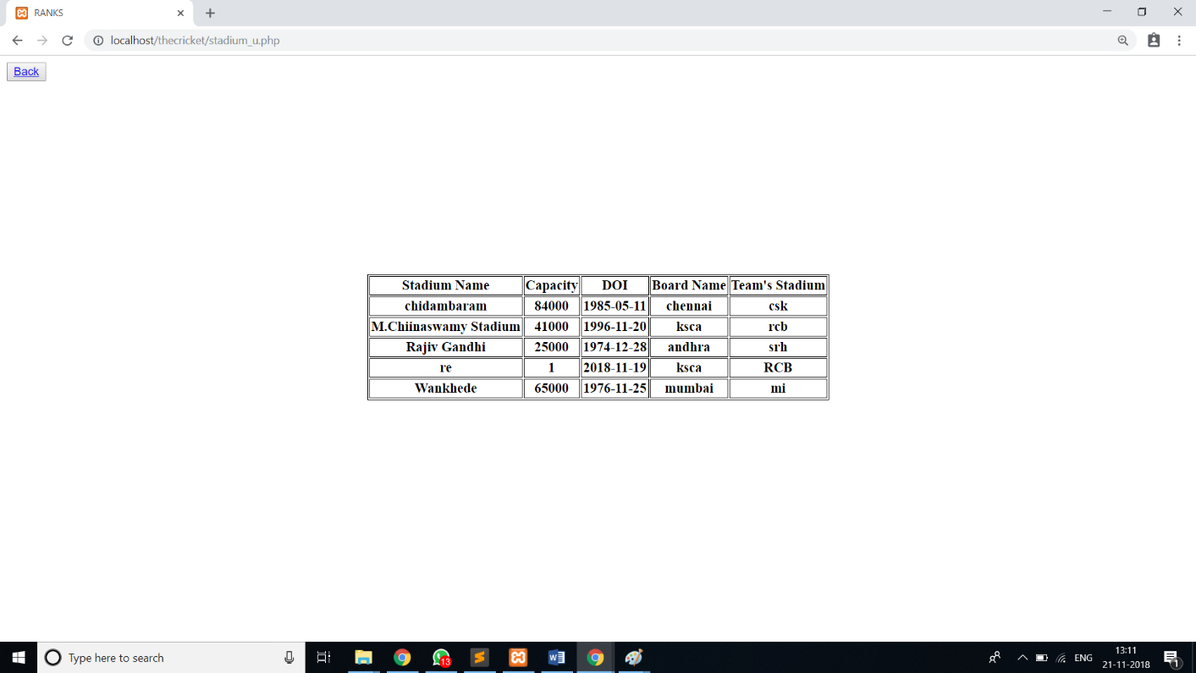

Figure7.22Stadium details

In the above Figure7.22, it shows window gives details about Stadiums.

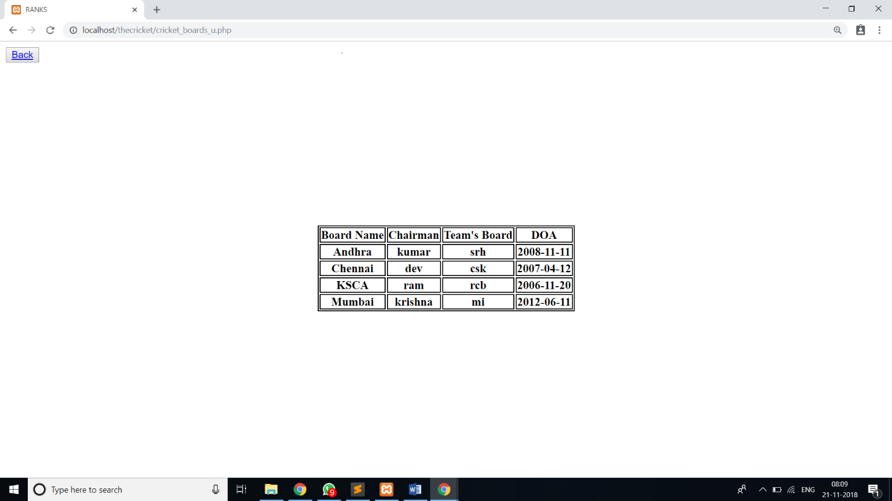

Figure6723Cricket boards

In the above Figure7.23, it shows window which gives information about Cricket boards.



Figure7.22 Player search for users

In the above Figure7.22,It shows the window where users can get Player details by searching the name.

**Chapter 8**

**8.1 Conclusion**

This project provides a flexible mechanism for user to access information of IPL. This project is designed to meet the requirements of the users. Therefore this helps in providing efficient information and managing the information of the IPL Cricket information.The users can access the player, matches, team information, awards of the IPL. The cricket association shares IPL information with viewers so that they can make profit.

**8.2 Future Scope**

This application can be easily implemented. We can add new features as and when we require. We can further implement this application to work efficiently for more number of users at a time and live chat and scores can be implemented.

**References**

1. RamezElmasri and Shamkant B. Navathe,“Database systems Models, Languages, Design and Application Programming”,6th Edition, Pearson,2017.
2. Ramakrishnan and Gehrke, “Database management systems”,3rd Edition McGraw Hill2014
3. SilberschatzKorth and Sudharshan, “Database System Concepts”, 6th Edition Mc-Graw Hill, 2013.
4. <http://www.phptpoint.com>
5. <https://www.tutorialspoint.com>